第３問 A You are planning to stay at a hotel in the UK.
You found useful information in the Q&A section of a travel advice website.

I'm considering staying at the Hollytree Hotel in Castleton in March 2021.
Would you recommend this hotel, and is it easy to get there from Buxton Airport?
(Liz)
Answer
Yes, I strongly recommend the Hollytree. I've stayed there twice. It's inexpensive, and the service is brilliant! There's also a wonderful free breakfast.
(Click here for access information.)
Let me tell you my own experience of getting there.
On my first visit, I used the underground, which is cheap and convenient.
Trains run every five minutes. From the airport, I took the Red Line to Mossfield. Transferring to the Orange Line for Victoria should normally take about
seven minutes, but the directions weren't clear and I needed an extra five minutes.
From Victoria, it was a ten-minute bus ride to the hotel. The second time,
I took the express bus to Victoria, so I didn't have to worry about transferring.
At Victoria, I found a notice saying there would be roadworks until summer 2021. Now it takes three times as long as usual to get to the hotel by city bus,
although buses run every ten minutes. It's possible to walk, but I took the bus
as the weather was bad. Enjoy your stay! (Alex)
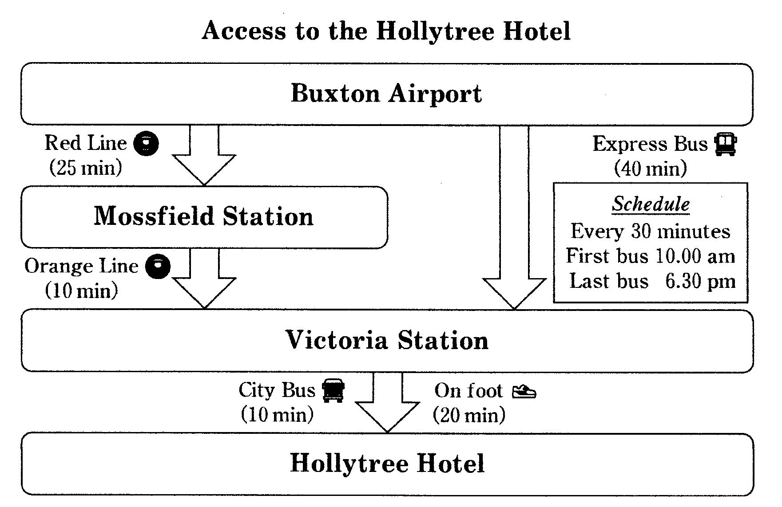
問２ You are departing on public transport from the airport at 2.00 pm
on 15 March 2021. What is the fastest way to get to the hotel? 17
1 By express bus and city bus 2 By express bus and on foot
3 By underground and city bus 4 By underground and on foot

B Your classmate showed you the following message
in your school's newsletter, written by an exchange student from the UK.
Volunteers Wanted !
Hello, everyone. I'm Sarah King, an exchange student from London.
I'd like to share something important with you today.
You may have heard of the Sakura International Centre.
It provides valuable opportunities for Japanese and foreign residents to get to know
each other. 問２ular events such as cooking classes and karaoke contests are held every month. However, there is a serious problem. The building is getting old,
and requires expensive repairs. To help raise funds to maintain the centre,
many volunteers are needed.
I learnt about the problem a few months ago. While shopping in town,
I saw some people taking part in a fund-raising campaign.
I spoke to the leader of the campaign, Katy, who explained the situation.
She thanked me when I donated some money.
2. Sarah donated money to the centre. ４２１３ 過去と過去完了に注意
She told me that they had asked the town mayor for financial assistance,
4. The campaigners asked the mayor for help.
but their request had been rejected. They had no choice but to start fund-raising.
Last month, I attended a lecture on art at the centre.
1. Sarah attended a centre event.
Again, I saw people trying to raise money, and I decided to help.
They were happy when I joined them in asking passers-by for donations.
We tried hard, but there were too few of us to collect much money.
With a tearful face, Katy told me that they wouldn't be able to use the building
much longer. I felt the need to do something more. Then, the idea came to me
3. Sarah made a suggestion to Katy.
that other students might be willing to help. Katy was delighted to hear this.
Now, I'm asking you to join me in the fund-raising campaign to help
the Sakura International Centre. Please email me today ! 問３
As an exchange student, my time in Japan is limited, but I want to make
the most of it. By working together, we can really make a difference.
Class 3A
Sarah King (sarahk@sakura-h.ed.jp)
セーラ・キング

問１
Put the following events (１～４) into the order in which they happened.
18 —> 19 —> 20 —> 21

問２
From Sarah's message, you learn that the Sakura International Centre 22
- gives financial aid to international residents
- offers opportunities to develop friendships
- publishes newsletters for the community
- sends exchange students to the UK

問３ You have decided to help with the campaign after reading Sarah's message. What should you do first? 23
1. Advertise the events at the centre.
2. Contact Sarah for further information.
3. Organise volunteer activities at school.
4. Start a new fund-raising campaign.

第４問 Your English teacher, Emma, has asked you and your classmate, Natsuki, to help her plan the day's schedule for hosting students from your sister school. You're reading the email exchanges between Natsuki and Emma
so that you can draft the schedule.

Hi Emma,
We have some ideas and questions about the schedule for the day out with our
12 guests next month. As you told us, the students from both schools are
supposed to give presentations in our assembly hall from 10:00 a.m. So, I've
been looking at the attached timetable. Will they arrive at Azuma Station at
9:39 a.m. and then take a taxi to the school?

We have also been discussing the afternoon activities. How about seeing
something related to science? We have two ideas, but if you need a third,
please let me know.

Have you heard about the special exhibition that is on at Westside Aquarium
next month? It's about a new food supplement made from sea plankton.
We think it would be a good choice. Since it's popular, the best time to visit will be
when it is least busy. I'm attaching the graph I found on the aquarium's homepage.

Eastside Botanical Garden, together with our local university, has been
developing an interesting way of producing electricity from plants. Luckily,
the professor in charge will give a short talk about it on that day
in the early afternoon! Why don't we go?

Everyone will want to get some souvenirs, won't they? I think West Mall,
next to Hibari Station, would be best, but we don't want to carry them around
with us all day.

Finally, every visitor to Azuma should see the town's symbol, the statue
in Azuma Memorial Park next to our school問３but we can't work out
a good schedule. Also, could you tell us what the plan is for lunch?
Yours,
Natsuki

Hi Natsuki,
Thank you for your email! You've been working hard. In answer to your question, they'll arrive at the station at 9:20 a.m. and then catch the school bus.

The two main afternoon locations, the aquarium and botanical garden,
are 問５ good ideas because both schools place emphasis on science education, and
the purpose of this program is to improve the scientific knowledge of the students.
However, it would be wise to have a third suggestion just in case.
Let's get souvenirs at the end of the day. We can take the bus to the mall arriving there at 5:00 p.m. This will allow almost an hour for shopping
and our guests can still be back at the hotel by 6:30 p.m. for dinner,
as the hotel is only a few minutes' walk from Kaede Station.

About lunch, the school cafeteria will provide boxed lunches.
We can eat under the statue you mentioned. If it rains, let's eat inside.

Thank you so much for your suggestions. Could you two make a draft
for the schedule?
Best, Emma

Attached timetable:
Train Timetable
Kaede — Hibari — Azuma
Stations |  | Train No.
 | 108 | 109 | 110 | 111
Kaede | 8:28 | 8:43 | 9:02 | 9:16
Hibari | 8:50 | 9:05 | 9:24 | 9:38
Azuma | 9:05 | 9:20 | 9:39 | 9:53

Stations |  | Train No.
 | 238 | 239 | 240 | 241
Azuma | 17:25 | 17:45 | 18:00 | 18:15
Hibari | 17:40 | 18:00 | 18:15 | 18:30
Kaede | 18:02 | 18:22 | 18:37 | 18:52

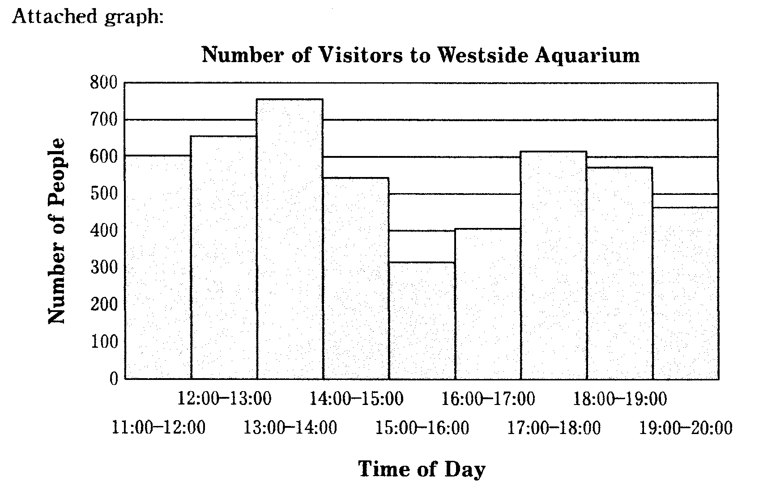
問１ The guests from the sister school will arrive on the number １ train
and catch the number 5 train back to their hotel.
1. 109 2.110 3. 111 4. 238 5. 239 6. 240
問２ Which best completes the draft schedule? 26
A : The aquarium B : The botanical garden C : The mall D : The school

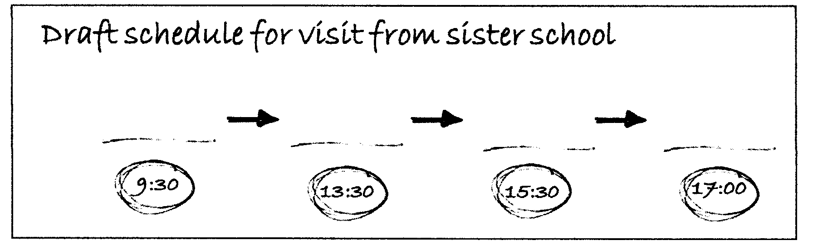
1. D—>A—>B—>C 2. D—>B—>A—>C
3. D—>B—>C—>A 4. D—>C—>A—>B
問３ Unless it rains, the guests will eat lunch in the 27
- botanical garden 2. park next to the school
- park next to the station 4. school garden

問４ The guests will not get around 28 on that day.
- by bus 2. by taxi 3. by train 4.on foot

問５ As a third option , which would be the most suitable for your program ?
- Hibari Amusement Park 2. Hibari Art Museum
3. Hibari Castle 4. Hibari Space Center

第３問 A You are planning to stay at a hotel in the UK.
You found useful information in the Q&A section of a travel advice website.

I'm considering staying at the Hollytree Hotel in Castleton in March 2021.
Would you recommend this hotel, and is it easy to get there from Buxton Airport?
(Liz)
Answer
Yes, I strongly recommend the Hollytree. I've stayed there twice. It's inexpensive, and the service is brilliant! There's also a wonderful free breakfast.
(Click here for access information.)
Let me tell you my own experience of getting there.
On my first visit, I used the underground, which is cheap and convenient.
Trains run every five minutes. From the airport, I took the Red Line to Mossfield. Transferring to the Orange Line for Victoria should normally take about
seven minutes, but the directions weren't clear and I needed an extra five minutes.
From Victoria, it was a ten-minute bus ride to the hotel. The second time,
I took the express bus to Victoria, so I didn't have to worry about transferring.
At Victoria, I found a notice saying there would be roadworks until summer 2021. Now it takes three times as long as usual to get to the hotel by city bus,
although buses run every ten minutes. It's possible to walk, but I took the bus
as the weather was bad. Enjoy your stay! (Alex)
問２ You are departing on public transport from the airport at 2.00 pm
on 15 March 2021. What is the fastest way to get to the hotel? 17
1 By express bus and city bus 2 By express bus and on foot
3 By underground and city bus 4 By underground and on foot

B Your classmate showed you the following message
in your school's newsletter, written by an exchange student from the UK.
Volunteers Wanted !
Hello, everyone. I'm Sarah King, an exchange student from London.
I'd like to share something important with you today.
You may have heard of the Sakura International Centre.
It provides valuable opportunities for Japanese and foreign residents to get to know
each other. 問２ular events such as cooking classes and karaoke contests are held every month. However, there is a serious problem. The building is getting old,
and requires expensive repairs. To help raise funds to maintain the centre,
many volunteers are needed.
I learnt about the problem a few months ago. While shopping in town,
I saw some people taking part in a fund-raising campaign.
I spoke to the leader of the campaign, Katy, who explained the situation.
She thanked me when I donated some money.
2. Sarah donated money to the centre. ４２１３ 過去と過去完了に注意
She told me that they had asked the town mayor for financial assistance,
4. The campaigners asked the mayor for help.
but their request had been rejected. They had no choice but to start fund-raising.
Last month, I attended a lecture on art at the centre.
1. Sarah attended a centre event.

Again, I saw people trying to raise money, and I decided to help.
They were happy when I joined them in asking passers-by for donations.
We tried hard, but there were too few of us to collect much money.
With a tearful face, Katy told me that they wouldn't be able to use the building
much longer. I felt the need to do something more. Then, the idea came to me
3. Sarah made a suggestion to Katy.
that other students might be willing to help. Katy was delighted to hear this.
Now, I'm asking you to join me in the fund-raising campaign to help
the Sakura International Centre. Please email me today ! 問３
As an exchange student, my time in Japan is limited, but I want to make
the most of it. By working together, we can really make a difference.
Class 3A
Sarah King (sarahk@sakura-h.ed.jp)
セーラ・キング

問１
Put the following events (１～４) into the order in which they happened.
18 —> 19 —> 20 —> 21

問２
From Sarah's message, you learn that the Sakura International Centre 22
- gives financial aid to international residents
- offers opportunities to develop friendships
- publishes newsletters for the community
- sends exchange students to the UK

問３ You have decided to help with the campaign after reading Sarah's message. What should you do first? 23
1. Advertise the events at the centre.
2. Contact Sarah for further information.
3. Organise volunteer activities at school.
4. Start a new fund-raising campaign.

第４問 Your English teacher, Emma, has asked you and your classmate, Natsuki, to help her plan the day's schedule for hosting students from your sister school. You're reading the email exchanges between Natsuki and Emma
so that you can draft the schedule.

Hi Emma,
We have some ideas and questions about the schedule for the day out with our
12 guests next month. As you told us, the students from both schools are
supposed to give presentations in our assembly hall from 10:00 a.m. So, I've
been looking at the attached timetable. Will they arrive at Azuma Station at
9:39 a.m. and then take a taxi to the school?

We have also been discussing the afternoon activities. How about seeing
something related to science? We have two ideas, but if you need a third,
please let me know.

Have you heard about the special exhibition that is on at Westside Aquarium
next month? It's about a new food supplement made from sea plankton.
We think it would be a good choice. Since it's popular, the best time to visit will be
when it is least busy. I'm attaching the graph I found on the aquarium's homepage.

Eastside Botanical Garden, together with our local university, has been
developing an interesting way of producing electricity from plants. Luckily,
the professor in charge will give a short talk about it on that day
in the early afternoon! Why don't we go?

Everyone will want to get some souvenirs, won't they? I think West Mall,
next to Hibari Station, would be best, but we don't want to carry them around
with us all day.

Finally, every visitor to Azuma should see the town's symbol, the statue
in Azuma Memorial Park next to our school問３but we can't work out
a good schedule. Also, could you tell us what the plan is for lunch?
Yours,
Natsuki

Hi Natsuki,
Thank you for your email! You've been working hard. In answer to your question, they'll arrive at the station at 9:20 a.m. and then catch the school bus.

The two main afternoon locations, the aquarium and botanical garden,
are 問５ good ideas because both schools place emphasis on science education, and
the purpose of this program is to improve the scientific knowledge of the students.
However, it would be wise to have a third suggestion just in case.
Let's get souvenirs at the end of the day. We can take the bus to the mall arriving there at 5:00 p.m. This will allow almost an hour for shopping
and our guests can still be back at the hotel by 6:30 p.m. for dinner,
as the hotel is only a few minutes' walk from Kaede Station.

About lunch, the school cafeteria will provide boxed lunches.
We can eat under the statue you mentioned. If it rains, let's eat inside.

Thank you so much for your suggestions. Could you two make a draft
for the schedule?
Best, Emma

Attached timetable:
Train Timetable
Kaede — Hibari — Azuma
Stations |  | Train No.
 | 108 | 109 | 110 | 111
Kaede | 8:28 | 8:43 | 9:02 | 9:16
Hibari | 8:50 | 9:05 | 9:24 | 9:38
Azuma | 9:05 | 9:20 | 9:39 | 9:53

Stations |  | Train No.
 | 238 | 239 | 240 | 241
Azuma | 17:25 | 17:45 | 18:00 | 18:15
Hibari | 17:40 | 18:00 | 18:15 | 18:30
Kaede | 18:02 | 18:22 | 18:37 | 18:52

問１ The guests from the sister school will arrive on the number １ train
and catch the number 5 train back to their hotel.
1. 109 2.110 3. 111 4. 238 5. 239 6. 240
問２ Which best completes the draft schedule? 26
A : The aquarium B : The botanical garden C : The mall D : The school

1. D—>A—>B—>C 2. D—>B—>A—>C
3. D—>B—>C—>A 4. D—>C—>A—>B
問３ Unless it rains, the guests will eat lunch in the 27
- botanical garden 2. park next to the school
- park next to the station 4. school garden

問４ The guests will not get around 28 on that day.
- by bus 2. by taxi 3. by train 4.on foot

問５ As a third option , which would be the most suitable for your program ?
- Hibari Amusement Park 2. Hibari Art Museum
3. Hibari Castle 4. Hibari Space Center

